* AEROCOOL STRIKE-X 500W 80+ BRONZE MODULAR POWER SUPPLY

Compatible with ATX 12V 2.3 and EPS 12V 2.92.  
Modular type power supply.   
Low Noise 13.9cm Fan with intelligent fan speed control.   
High-Efficiency (up to 85%) – 80+ Bronze Certified.   
Supports Dual Core CPU, ATI CrossFire, NVIDIA SLi and all Multi-Core GPU technologies.   
Built in next generation 6+2 pin PCI-Express graphic card connector.   
Active Power Factor Correction (PF>0.99).   
Extremely good voltage regulation (±5%): provides steady power input.   
High reliability: MTBF>120,000 hours.   
Green power design that meets EuP requirements.   
 Protections: Over Current, Over Voltage, Over Wattage, Over Temperature and Short-Circuit protection.   
 Safety / EMI Approvals: CE, CB, TUV, FCC, UL.

|  |  |
| --- | --- |
| MODEL | EN53648 |
| TYPE | ATX 12V 2.0 & EPS 12V 2.92 |
| MAX POWER | 500w |
| # OF FANS | 1 |
| PFC | ACTIVE |
| +12V RAILS | SINGLE |
| NVIDIA SLI | READY |
| AMD CROSSFIRE | READY |
| MODULAR | NO |
| EFFICIENCY | 80+% BRONZE |
| PROTECTION | OCP/ OVP/ OPP/ OTP/ SCP/ UVP |
| MTBF | 120,000 hours. |
| CONNECTORS | -1 x 20+4 Pin -1 x 4+4 pin -4 x HDD 4 pin connector -1 x FDD 4 pin connector -4 x SATA -2 x 6+2 PCI pin connectore |
| FEATURES | 1. Powerful "X" theme Gaming PSU. 2. New black-green color combination for Amry Edition scheme. 3. Low Noise 13.9cm Fan with intelligent fan speed control. 4. High-Efficiency 80Plus Bronze. 5. Black Sleeving to reduce the cable mess inside your chassis and improves the air flow of your system. 6. Supports Dual Core CPU, ATI CrossFire, NVIDIA SLi and all Multi-Core GPU technologies. 7. Built in next generation 6+2 pin PCI-Express graphic card connector. 8. Active Power Factor Correction (PF>0.99) 9. Extremely good voltage regulation (±5%): provides steady power input. 10. High reliability: MTBF>120,000 hours. 11. Green power design that meets ErP requirements. 12. Bullet hole stickers for your personal modding accessories. 13. Protections: Over Current, Over Voltage, Over Power, Over Temperature, Under Voltage and Short-Circuit protection. 14.Safety / EMI Approvals: CE, FCC, TUV, Gost, CB. |

Some features, capabilities and technologies only work on certain BIOS configurations, parts and/or processors installed  
for more information visit: [AEROCOOL Power Supply](http://www.aerochttp/www.aerocool.com.tw/power-supply/strike-x/80.html)

Caution:  
Please be aware that there is a certain risk involved with overclocking, including adjusting the setting in the BIOS or using the third-party overclocking tools.  
Overclocking may affect your system stability, or even cause damage to the components and devices of your system. It should be done at your own risk and expense. We will not be held responsible/liable for possible damages caused by overclocking.

*Protections:  
- SCP - Short circuit protection  
- OPP - Overpower (overload) protection  
- OCP - Overcurrent protection  
- OTP - Overtemperature protection  
- OVP - Overvoltage protection  
- UVP - Undervoltage protection

The specification, price and photo are subject to change without prior notice. The brand and product names are trademarks of their respective companies. Any configuration other than original product specifications is not guaranteed.

* AEROCOOL STRIKE-X 600W 80+ BRONZE POWER SUPPLY

Powerful “X” theme Gaming PSU   
Compatible with ATX 12V 2.3 and EPS 12V 2.92  
Low Noise 13.9cm Fan with intelligent fan speed control  
High-Efficiency (up to 85%) – 80+ Bronze Certified  
Supports Dual Core CPU, ATI CrossFire, NVIDIA SLi and all Multi-Core GPU technologies.   
Built in next generation 6+2 pin PCI-Express graphic card connector.   
Active Power Factor Correction (PF>0.99)   
Extremely good voltage regulation (±5%): provides steady power input  
High reliability: MTBF>120,000 hours   
Green power design that meets EuP requirements   
Protections: Over Current, Over Voltage, Over Wattage, Over Temperature and Short-Circuit protection   
Safety / EMI Approvals: CE, CB, TUV, FCC, UL

* COOLER MASTER B600 V2 600W 80+ POWER SUPPLY.

80 plus EU 230V certified  
Silent 120mm HDB fan with intelligent fan-speed control, to enhance longevity and help reduce noise in power unit.  
Green power design to meet ErP 2013 Lot6 & all new CE energy saving regulation  
Powerful +12V rail for strong resistance to any overloading  
Fully protection ( OCP/OVP/SCP/OPP ) with build-in Over Temperature Protection ( OTP )

* COOLER MASTER THUNDER 450W POWER SUPPLY

**Intelligent Fan Speed Control**  
Speed control makes the 120 mm fan adept for any user’s circumstances and need.

**Multiple Protection Design**  
over Voltage Protection (OVP), Over Power Protection (OPP), Over Current Protection (OCP), Short Circuit Protection (SCP).

**Massive Bulk Capacitor**  
Producing hold times >14ms upon full loading.

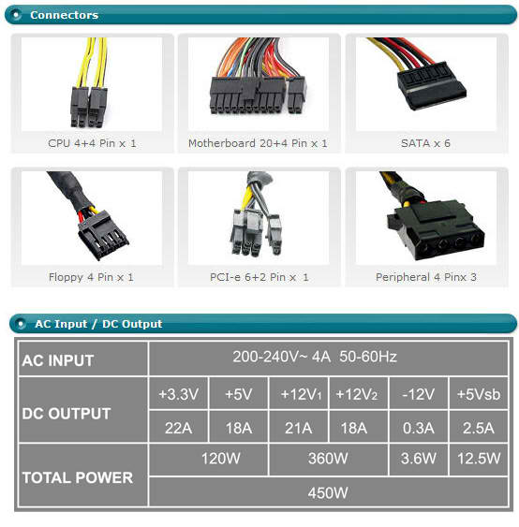

* COOLER MASTER THUNDER 500W 80+ POWER SUPPLY

**Dual 12 V Power Rail**  
Tackling challenges from the most power-intensive peripherals head on, double 12 V power rails provide ample power and strong resistance to any overloading.

**Double-Layer EMI Filter**  
Dual protection from electromagnetic interference, thus restraining noise and interference for greater protection for you and your connections.

**Intel Compliant**  
Intel ATX 12V v 2.3

**Intelligent Fan Speed Control**  
Speed control makes the 120 mm fan adept for any user’s circumstances and need.

**Multiple Protection Design**  
Over Voltage Protection (OVP), Over Power Protection (OPP), Over Current Protection (OCP), Short Circuit Protection (SCP).

**Massive Bulk Capacitor**  
Producing hold times >14ms upon full loading.

**And More**  
– Multiple updated connectors for all types of interfaces (PCIe, SATA etc.)  
– High reliability with an MBTF of at least 100,000 hours of use.

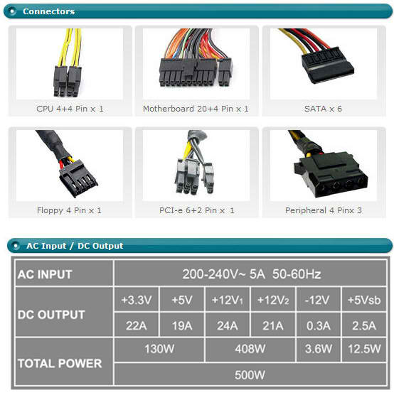

* CORSAIR VS450 450W POWER SUPPLY

VS450ATX 12V V2.3 / Output 34A / 12 cm fanCP-9020096-EU

VS450ATX 12V V2.3 / Output 34A

The Corsair VS450 is a great choice if you’re building a home or office system with lower power demands, but you still demand the compatibility and reliability that Corsair is known for. Real power The VS450 delivers a guaranteed 450 Watts of continuous power. With 0.99 Active Power Factor Correction, you get the peace of mind from knowing that your components are protected from uneven power delivery. And, a dedicated single +12V rail saves you from the hassle of balancing your components across multiple power cables. Low noise, high efficiency The 120mm fan is thermally controlled, so it only spins at maximum speed when it’s pushed hard – and even at full load, it’s pretty quiet. Smart design features like this are why VS450 offers up to 85% efficiency. Your PC system will generate less heat, and you’ll enjoy lower energy bills. Sophisticated design The black powder-coated enclosure and the black-sleeved cables give any system a polished look. You’re building a PC, not a battleship, and with the VS450 you can avoid that look of unpainted steel that you’ll find on so many entry-level power supplies. Reliability you can count on VS450 is backed with a three-year warranty, and you get lifetime access to Corsair’s legendary technical support and customer service.

* CORSAIR VS550 550W POWER SUPPLY

**A dedicated single +12V rail offers maximum compatibility with the latest components**

**Active Power Factor Correction (PFC) with PF value of 0.99**

**AC input from 200~240VAV**

**Over-voltage, under-voltage, over-current, and short circuit protection provide maximum safety for your critical system components**

VS550: the entry-level 240V power supply with high-end features

The Corsair VS550 is a great choice if you’re building a home or office system with lower power demands, but you still demand the compatibility and reliability that Corsair is known for.

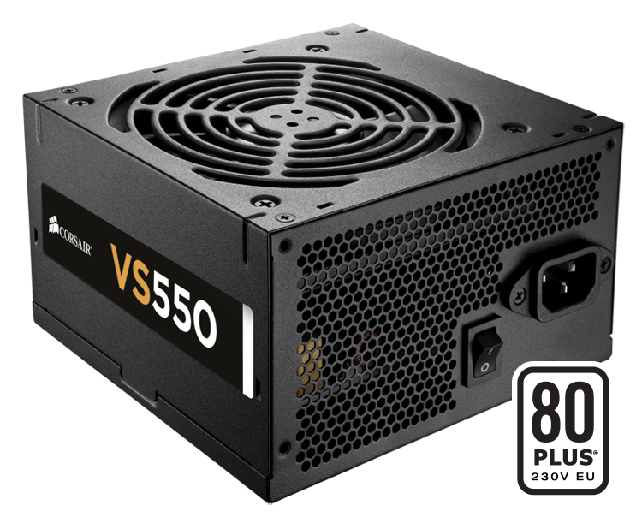

Real power

The VS550 delivers a guaranteed 550 Watts of continuous power. With 0.99 Active Power Factor Correction, you get the peace of mind from knowing that your components are protected from uneven power delivery. And, a dedicated single +12V rail saves you from the hassle of balancing your components across multiple power cables.

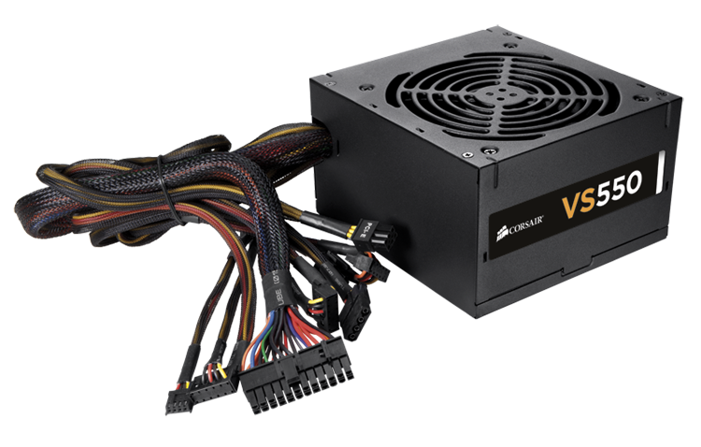

Low noise, high efficiency

The 120mm fan is thermally controlled, so it only spins at maximum speed when it’s pushed hard – and even at full load, it’s pretty quiet. Smart design features like this are why VS550 offers up to 85% efficiency. Your PC system will generate less heat, and you’ll enjoy lower energy bills.

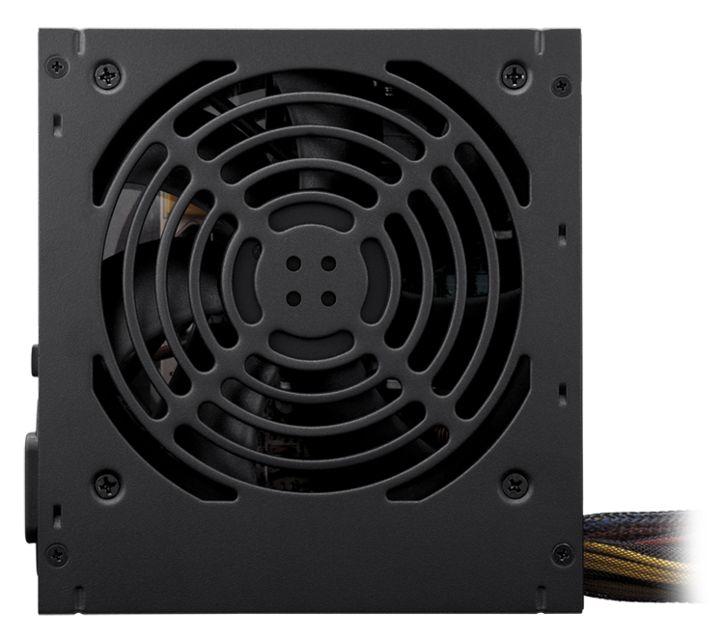

Sophisticated design

The black powder-coated enclosure and the black-sleeved cables give any system a polished look. You’re building a PC, not a battleship, and with the VS550 you can avoid that look of unpainted steel that you’ll find on so many entry-level power supplies.

Reliability you can count on

VS550 is backed with a three-year warranty, and you get lifetime access to Corsair’s legendary technical support and customer service.

* CORSAIR VS650 650W POWER SUPPLY

A dedicated single +12V rail offers maximum compatibility with the latest components  
Active Power Factor Correction (PFC) with PF value of 0.99  
AC input from 200~240VAV  
Over-voltage, under-voltage, over-current, and short circuit protection provide maximum safety for your critical system components

* COUGAR SL500 500W POWER SUPPLY

ATX12V  
115 / 230 V 50/60 Hz  
+3.3V@22A, +5V@20A, +12V1@19A, +12V2@20A, -12V@0.5A, +5VSB@2A

* FSP AURUM 500 80PLUS GOLD SLI 500WATTS POWER SUPPLY

Complies with ATX12V v2.3 & EPS12V v2.92  
High efficiency > 90%  
80 PLUS GOLD certified  
4 +12V output circuits  
6 + 2pin PCI-Express graphic card connector ready  
Industrial Grade Component: Japanese Capacitor  
Quiet and long-lasting 120mm FDB fan  
Complete Protections: OCP, OVP, SCP, OPP, UVP  
Multiple Safeties Approved: CE, FCC, CB, UL, TUV, BSMI, CCC, GOST, KCC